MGMS – Proposal Management

Functional Specification Document

Ver. 1.4

Version History
Date | Description
21-Nov-2010 | First Draft

Table of Contents

Version History 2
1 Introduction 4
1.1 Purpose 4
1.2 Scope 4
1.3 Assumptions 4
1.4 Constraints 4
2 Proposal Management 4
3 Business Rules 6
4 Status Messages 6

Introduction

Purpose

This document provides the requirements and functional specifications for the Asset Purchase module of the Multisite Grant Management System project.
This is not a project plan or a design document. It is a guide for system architecture and development, not for phasing, timelines or deliverables.
Finally, this is a ‘living document’ and the specification will change, continuously, as the project proceeds. More details will be added and the existing information edited as the requirements, scenarios and use cases evolve in the course of the project.

Scope

Assumptions

Constraints

Proposal Management

This section lists out all the notifications published by all the institutions in the GMS.

On this page, the interested institution users (prospective grantees) can:
- View the project name, notification date, grantor institution’s name, last date for submission of proposal etc.
- View the notification details
- Upload their proposal thereby setting a status “Submitted” and then
- Apply for the project.

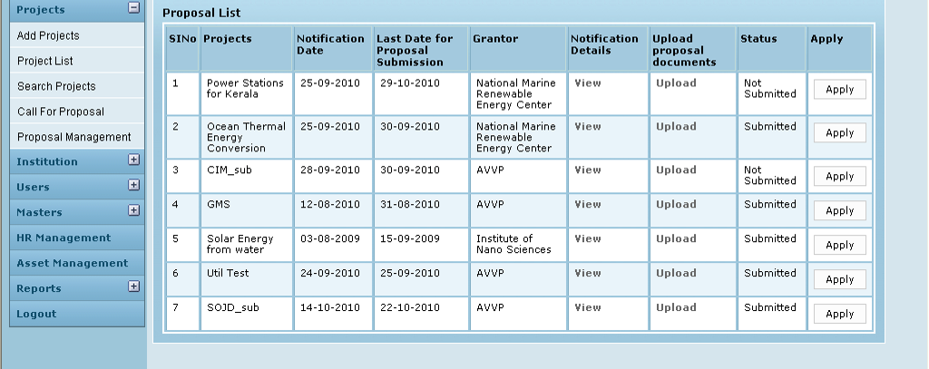

Field /Label | Input-Control | Data Type | Remarks
Proposal List
SlNo | Auto increment populated
Projects | Auto populated | String | projects>name
Notification Date | Auto populated | datetime | notification>notification_date
Last Date for Proposal Submission | Auto populated | datetime | notification>  proposal_submission_last_date
Grantor | Auto populated | String | party>name_of_the_institution
Notification Details | “View” - link
Upload Proposal documents | “Upload” - link
Status | Auto populated | String | proposal>lockedyn
Apply | “Apply” - button

Upload Attachments

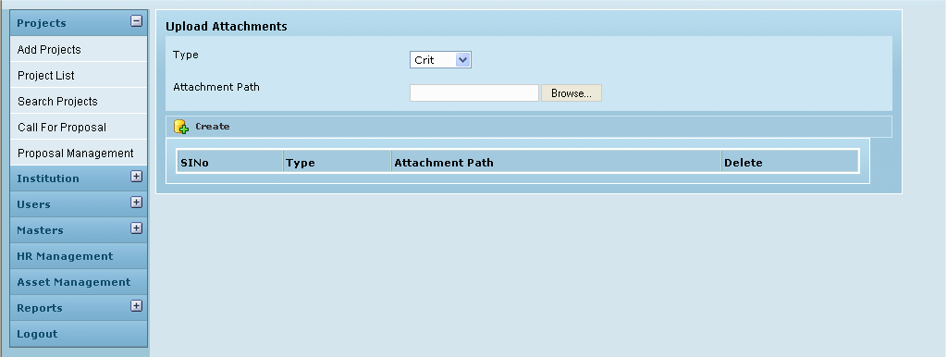

Field /Label | Input-Control | Remarks
Type | Listbox | attachment_type>type
Attachment Path | Text box – auto populated | Upload file
 | “Browse” button
Create | Button
(table fields)
SlNo | Auto populated
Type | Auto populated | attachment_type>type
Attachment Path | Auto populated | notifications_attachments> attachment_path
Delete | Button | Removes attachment

Business Rules

Status Messages

Sl No | Status Message
1 | Created Successfully
2 | Updated Successfully
3 | Deleted Successfully
4 | The Requested Record Not Found
5 | The Record can't be deleted, Already in use
6 | The Record Already Exists
7
8

